**Image and Tag**

* Any docker image represents some application. Every application will have multiple versions.
* In Docker to represent application we use name of image and to represent version we use tag. The convention <image-name>:<tag>

hello-world => hello-world:latest

* If the tag is not passed docker assumes the tag to be latest  
  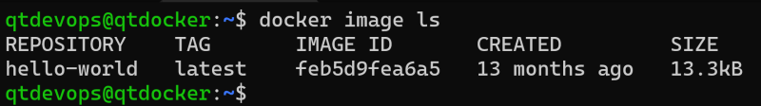
* Along with Repository (image name) and tag we also have image-id  
  